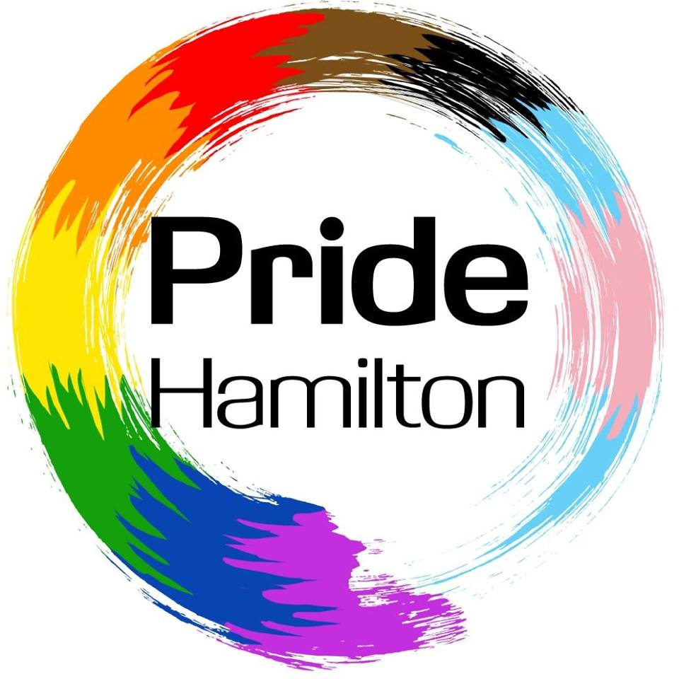
Pride Hamilton 2018
June 17, 2018, Gage Park, Hamilton, Ontario

I am writing to you as a member of the Pride Hamilton 2018 committee. This year, the committee is dedicated to supporting a number of events throughout the month of June, but ultimately focused on creating a Park Event on Sunday June 17 to celebrate Hamilton’s beautiful and diverse LGBTQ2SIA+ community.
Last year’s Pride Hamilton Park event attracted thousands of attendees throughout the day, and offered a range of activities and entertainment strongly rooted in the local LGBTQ2SIA+ community.
This year, due to phenomenal response and to meet interest demand, the decision was made to move our Pride Hamilton Park Day Event to Gage Park. Gage Park historically has been home to many of Hamilton’s most beloved and well-attended festivals and will set the stage for our best Pride Hamilton Park Day event yet.
Early interest, momentum and inquiries to participate are up significantly, allowing us to project a 250% increase in attendance for this year’s event. In addition to interest and inquiries, we have seen huge increases in reach on our Social Media platforms. Our average monthly reach is now upwards of 25,000, and amplification rate continues to rise as the excitement builds leading towards our Park day event and Pride month in June.
In addition to this, we have also seen a substantial increase in local business owners and community members planning their events to tie in with Hamilton’s celebration of Pride month. We have 30+ events planned for the month of June alone that will be supported and promoted by Pride Hamilton.
All of this activity will culminate with our big Park Day event celebration at Gage Park, June 17. In response to our call out, we’ve secured a long list of well-known performers, vendors, and community resource representatives that will take part, and look forward to celebrating with us, while also gaining exposure to thousands of community members. You too can benefit from the ability to connect to a growing community that is largely underserved. A recent study by the International Gay and Lesbian Chamber of Commerce and the National Post pegged the buying power of the LGBTQ2SIA+ community in Canada at just over $100 billion. The LGBTQ2SIA+ market is bigger than any ethnic market in Canada, and is fast approaching the size of the youth market. Despite this market being a viable target, most businesses struggle to connect to the LGBTQ2SIA+ community and harness its buying power. Sponsorship of Pride events is one step in the right direction in supporting the LGBTQ2SIA+ community while also marketing to them directly.
This year’s Pride Hamilton Park Day event will be our best yet, and is only the beginning as we continue to build Pride Hamilton to better connect with the LGBTQ2SIA+ community and the Hamilton community as a whole. We look forward to a successful Pride Hamilton Park Day event, Pride month and seek to build this framework into a year-round celebration of the pride we share for our community and the beautiful city of Hamilton that we call home.
Your sponsorship allows you to be part of this mission, while also capitalizing on an excellent opportunity to connect to the community as a whole. Sponsorship options are available in the document provided, with a vast range of options to suit your marketing needs and goals. Individual ads can also be purchased for our Pride Hamilton Park Day event program. Lastly, in addition to your sponsorship, we accept individual contributions in any amount.
Thank you for sharing your pride with us – any questions, please contact pridehamilton2018@gmail.com directly, look forward to providing any insight needed.
Proudly yours,
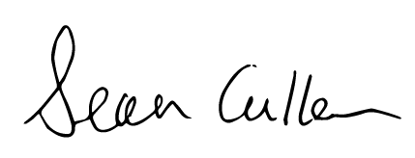
Chairperson, Pride Hamilton 2018
Pride Hamilton 2018
Sponsorship and Donation Form

Sponsor/Patron/Advertiser/Donor Name:

Contact Name:

Email:

Phone Number:

Address:

City:

Province:

Postal Code:

Please select one of the following sponsorship/donation levels

I would like sponsor the following area of the park, if still available:

Stage - $5000 ____ Entertainment Area - $1600 ____ Beer Garden - $4000 ____

Artists Market - $1200 ____ Family Area - $1200 ____

I would like to sponsor at the following level:

Rainbow - $2000 ____ Platinum - $1000 ____ Gold - $500 ____ Silver - $250 ____

I would like advertising in the full colour Official Pride Hamilton Park Day Program:

Full Page - $900 ____ 1/2 Page - $600 ____ 1/4 Page - $300 ____

Cheques and Certified cheques can be made payable to The AIDS Network.

Credit card and cash payments can be arranged by contacting pridehamiltonfinance@gmail.com

The financials for Pride Hamilton are held in trust by
The AIDS Network, 101 – 140 King St E, Hamilton, ON, L8N 1B2
Charitable #118951383RR0001

